**Output Screenshots:**

**View result tree:**

Login get Error due to assertion ,HTML assertion present in the login controller.

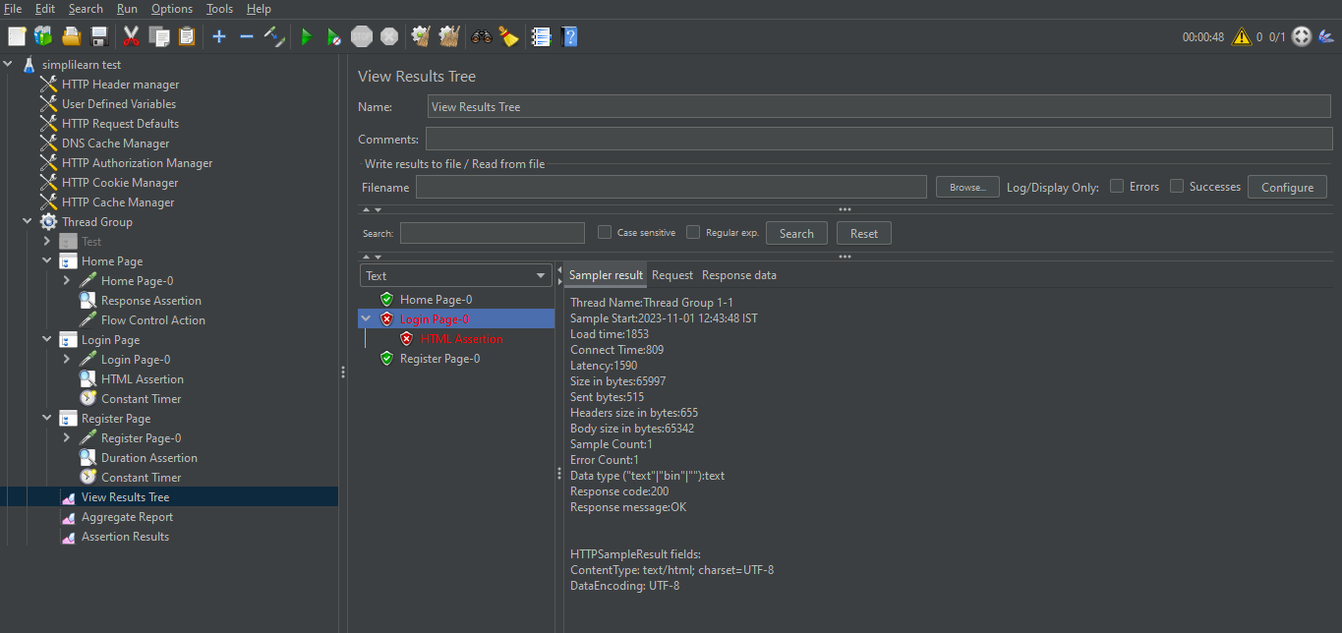

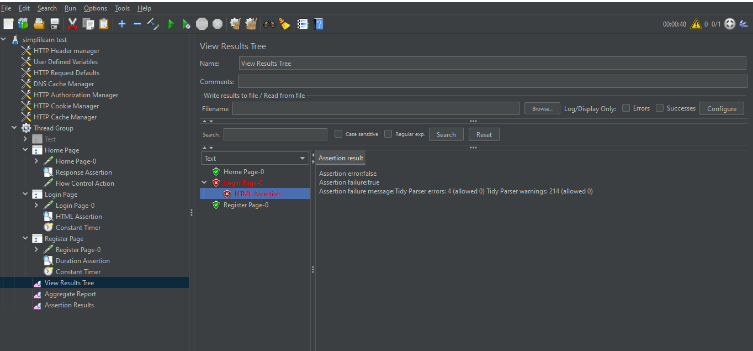

**Warnings and errors stored in file:**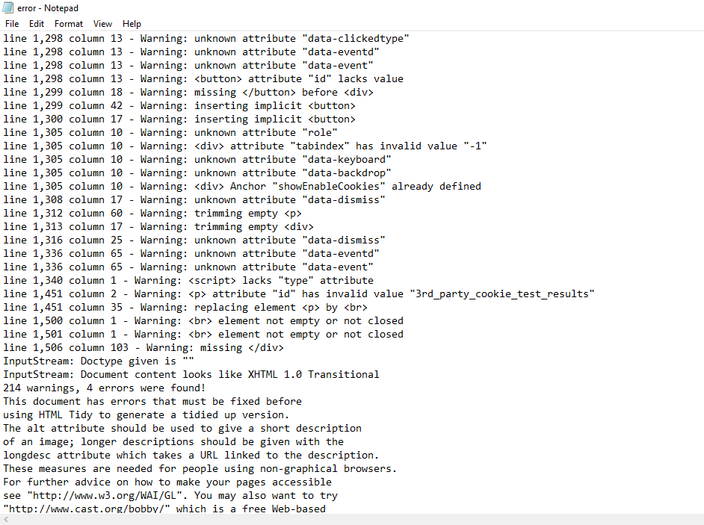

**Aggregate report:**

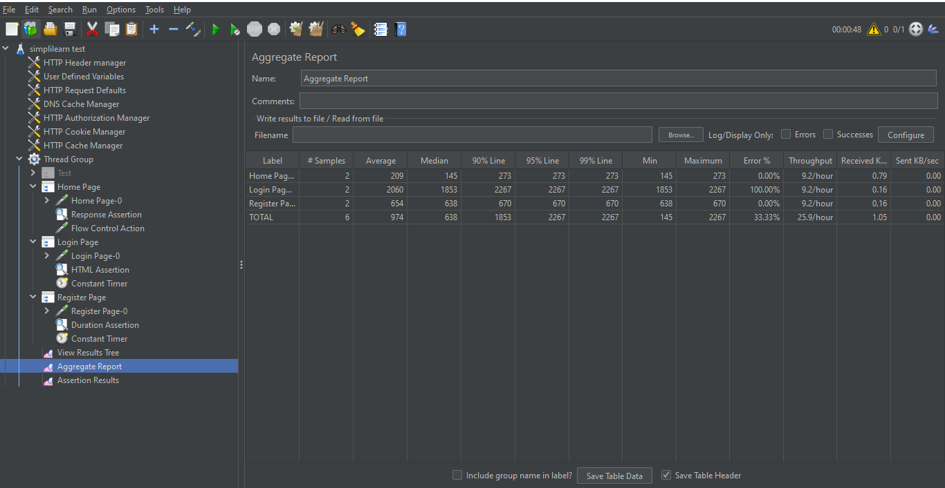

**Assertion Result:**

